**Adidas Interactive Sales Dashboard**

**Overview**

This project is an interactive sales dashboard for Adidas, developed using Streamlit. It leverages various Python libraries, including pandas, Plotly, and PIL, to read sales data, visualize it, and provide insightful analytics. The dashboard is designed to help users explore and analyze sales data interactively.

**Features**

**Data Visualization**

Bar charts, line charts, and tree maps for visualizing total sales by retailer, over time, by state, and by region and city.

Dual-axis chart to display total sales and units sold by state.

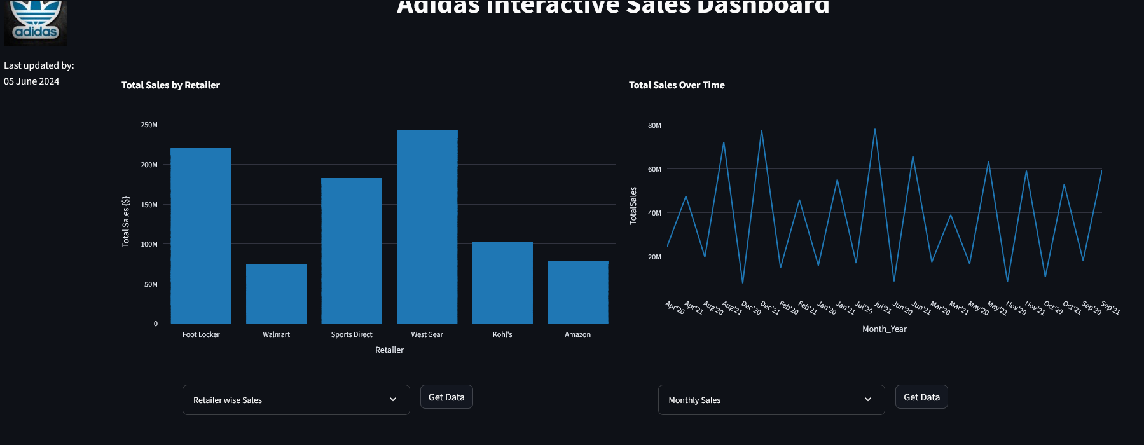

**Data Interaction**

Expanders to view detailed data for retailer-wise sales, monthly sales, sales by units sold, and total sales by region and city.

Download buttons to export data in CSV format for of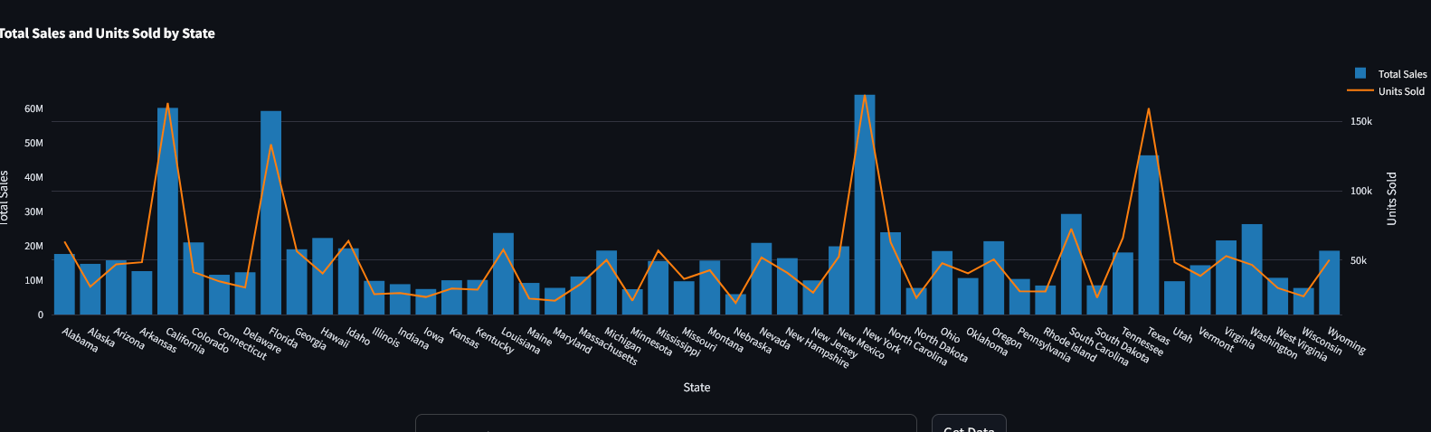e analysis.

**Customization**

Custom page layout and styling using Streamlit's layout options and custom CSS.

Display the last updated date dynamically.

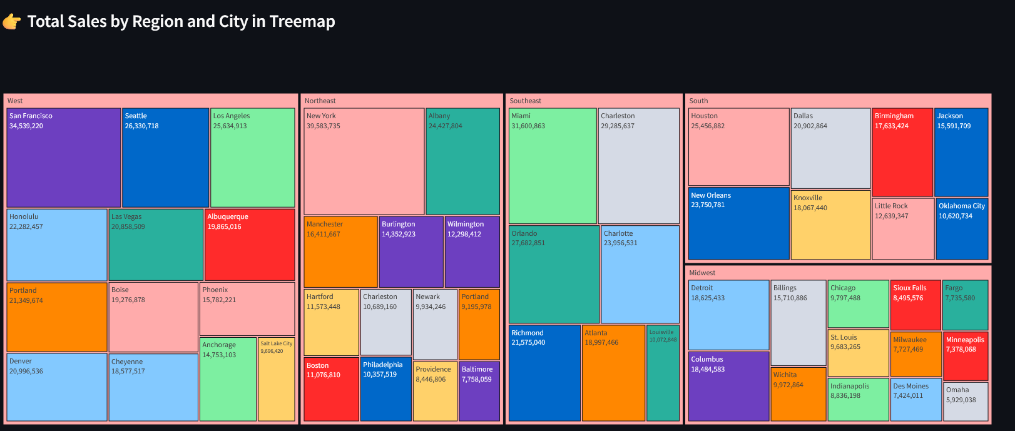

**Data Source**

The sales data is read from an Excel file (`Adidas.xlsx`) that contains detailed sales records, including retailer names, total sales, invoice dates, states, and units sold.

**Visualization Details**

**Total Sales by Retailer**

A bar chart that shows total sales for each retailer, providing a clear comparison between different retailers.

**Total Sales Over Time**

A line chart that depicts the trend of total sales over time, helping to identify patterns and seasonal effects.

**Total Sales and Units Sold by State**

A combined bar and line chart that shows total sales as bars and units sold as a line, giving a comprehensive view of sales performance across states.

**Total Sales by Region and City**

A treemap visualization that breaks down total sales by region and city, offering a hierarchical view of sales distribution.

**Conclusion**

This interactive sales dashboard provides a powerful tool for analyzing Adidas sales data, enabling users to gain insights and make data-driven decisions. The combination of Streamlit and Plotly ensures a responsive and visually appealing interface.